Exercise 1

Omri Bar Oz – 313325961, Ilana Pervoi – 318271640

Question 2:

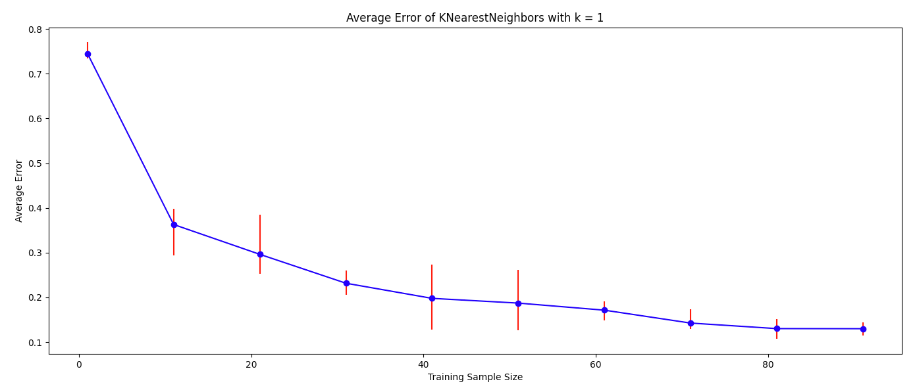

1. We can observe that when the training sample size increases, the average test error decreases. It happens because when we increase the sample size, our samples become a better representation of the distribution and each point in the test set has a higher probability to find a closer neighbor from the samples with the same label during the NN algorithm run.
2. Yes. We get different results in different runs with the same sample size, since in each run the samples are chosen randomly, meaning they are not the same as in previous runs and therefore we might get a sample set with only 1 or 2 labels, which will cause us more errors than samples that are diverse and more representative of our distribution.
3. Yes, generally the error bars tend to decrease in size when the sample size increases. However, as we can observe there are cases in which the sample size increases, and yet the error bars increase, because as stated in section c, the accuracy of the model depends on how well the samples represent the distribution.

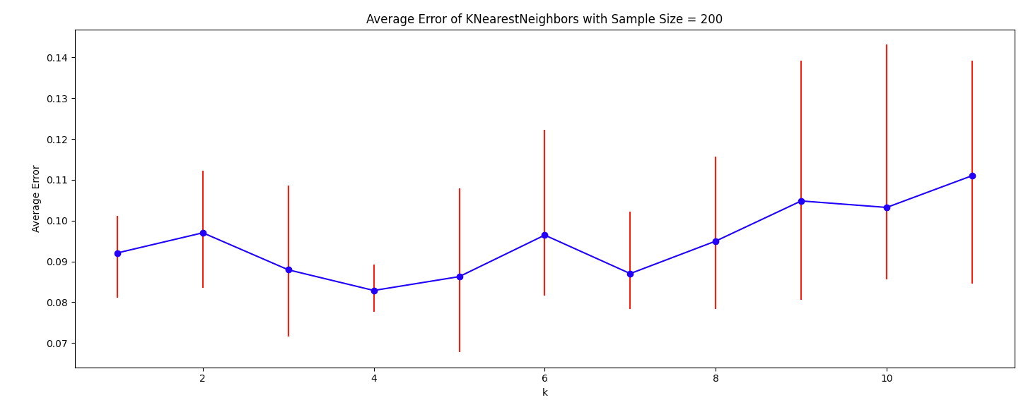

1. TODO
2. TODO

Question 3:

1. Need to prove:  
   for any two pairs if then

Proof:  
 and so WLOG we can decide that and .  
We obtain:

Recall that and of is c-Lipschitz with respect to the Euclidean distance, hence from a property we learned in class:

1. Need to prove:  
   under the given assumptions,

Proof:

So, we will show that .

Let and such that .  
Since is in at least one ball in the set of balls of radius that covers the space of points and there is an assumption that has a point in this ball as well, we obtain

Now, from the assumptions on we know that and has the same label

Question 4:

1. Let hypothesis class of constant functions. therefore where . By definition:  
   .  
   Hence:
2. As we say in class, every example in the will be labeled by with the label with the highest probability. In this case, if a rabbit is older than 25 months old, it has a probability of 50% or more to be black, so will label it as black. More formally:
3. We cannot calculate the error of the predictor we gave in e), since we don’t know how the rabbits ages are distributed, and in order to calculate the error we need to know where x is a rabbit from .
4. As we saw in class, where , and is the sample size:  
   in our case: therefore:  
   We are allowed to use this formula for because has a deterministic label condition on the example, whereas does no as it has 2 different labels for the same example.

Question 4: Let . Consider the hypothesis class of thresholds:  
Let be a distribution over and suppose that the marginal distribution of on is uniform on and that for , for any

1. In this section we will talk about N evenlty-spaced threshold for an integer N:  
   We assume that is realizable by . We will use the PAC bounds for finite hypothesis classes we learned in class with . We can use it as is finite and , and is realizable by it and we get:
2. Let . Let .  
   by the definition, an example will get 1 only if it is higher or equal to and 0 only if it is lower than . Therefore:
3. Let with : . Let be the hypothesis returned from some ERM algorithm trained on S with . We will show that for by showing that and for every .  
   Let Then . Notice that and equality happens only if , by the definition of . So, for every and for every . Because and it holds that and it implies that is labeling correct all the points in S which implies that .  
   Let . Wlog assume that .  
   It is easy to see that . While true label is 1, will label as 0, which implies that .  
   This concludes that an ERM algorithm will return a for .  
   Let be the hypothesis returned by an ERM algorithm. then by sub-question (b),
4. Let . Then:  
   this holds for as well because .  
   Let be the hypothesis returned by a ERM algorithm with .
5. We will use . by the last sub-question:  
   we want it do be greated than then: